Equine Gastric Ulcer Syndrome (EGUS)

Gastric ulceration is an extremely common condition affecting all types of horses. While the clinical relevance of gastric ulceration is unclear in some cases, gastric ulcers can produce a variety of abnormal clinical symptoms. The risk of gastric ulceration varies with breed, use and level of training, and it is normally triggered by management changes, an increase in training intensity, high carbohydrate diets and stressful situations (i.e. transport, shows, windsucking etc.). Horses suffering from this condition often display vague /nonspecific signs including weight loss, mild recurrent colic, selective/poor appetite, dull coat, attitude changes, resistance to being ‘girthed up’ and decreased performance. The severity of ulcers can vary and mild ulceration may cause few clinical problems, however deep and extensive ulcers are likely to cause significant discomfort.

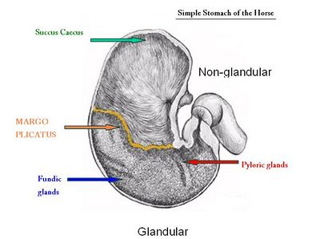

Figure -1.

The horse has a small stomach (about the size of a rugby ball). The upper third (squamous part) contains no glands, it has minimal protective mechanisms and mainly serves as a reservoir feeding fibre (eg. Hay etc) down into the lower 2/3 of the stomach, (the glandular part, where the process of digestion actually starts). The glandular part produces hydrochloric acid. Fibre physically protects the lining of the squamous part of the stomach from coming into contact with the acid, especially whenever your horse is exercised (and splashes it about). There is a visibly defined junction, between the two parts of the stomach (the margo plicatus). The glandular part of the stomach has numerous glands responsible for acid secretion and is also responsible for the production of acid-retarding bicarbonate, it has a mucous layer that protects its surface. Most of the ulcers occur in the area near to the margo plicatus. - Figure 1. However, it must be noted that ulcers can occur on either the squamous OR the glandular part of the stomach. It now appears that these may be two distinct AND separate conditions.

Ulceration is not just a disease of performance horses, 36-53% of pleasure horses and ponies are also affected. Foals are at particular risk of gastric ulcers, especially as a consequence of other medical conditions. Horses (and especially ponies) on long term NSAIDS (bute) may be at risk of developing gastric ulceration.

You can estimate the risk to your horse using the website www.equinegastriculcers.co.uk.

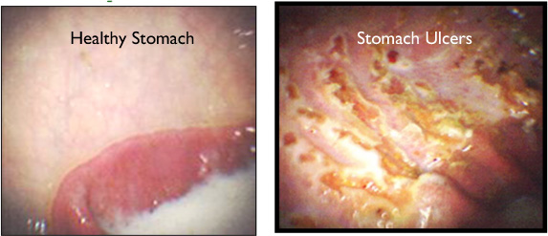

Gastroscopy is the only way to reliably diagnose and grade the severity of ulceration. The horse must first be fasted for a minimum of 12 hours, (water is withheld for a minimum of four hours), this procedure involves passing a flexible camera into the horse’s (empty) stomach. A positive diagnosis allows us to suggest appropriate management strategies and to establish the most cost-effective treatment plan. NB: Many Insurance Companies now insist on the confirmation of the diagnosis EGUS before they will authorize a course of treatment of horses with omeprazole. We recommend having a subsequent follow up Gastroscopy to confirm resolution of this condition after a course of treatment for EGUS.

Treatment of EGUS.

If ulcers are diagnosed they should be treated with anti-ulcer medications (eg. Omeprazole, -this reduces the production of acid, allowing the ulcers to heal). Omeprazole can be fed daily or injected once a week. Oral omeprazole appears to be most effective when administered first thing in the morning, (about 20-30 minutes BEFORE breakfast). Spontaneous ulcer healing can occur, but drug therapy is vital in most cases, and is effective regardless of training intensity. We generally recommend a course of 4-6 weeks with Omeprazole. The treatment of glandular ulcers is much more difficult and often necessitates the use of Sucralfate and or Misoprostol in addition to the Omeprazole. Some horses may need to be maintained on (lower doses) of these drugs semi permanently subsequently.

Management changes

These are just as important when treating EGUS and include the following:

- Continuous access to good quality grass is considered the ‘ideal roughage’. When access to pasture is not possible, continuous access to (good quality) hay should be provided. Use small hole nets if necessary to ensure that he cannot ‘bolt his feed’ and then have an empty stomach for several hours.
- Alfalfa has good acid buffering capacity, (it helps neutralize the stomach acid), this should be added to the hay ration.
- Grain and concentrates should be fed sparingly, as they can ferment to form acid by-products.
- Concentrate meals should be more than six hours apart, (see above).
- Adding 50-100mls of corn oil in his short feeds twice daily, has been shown to increase calorie intake and to help reduce acid production.
- Constant access to clean water.
- Feeding a scoop of fibre (eg Hi Fi Lite, /Alfalfa) 30-60 minutes prior to exercise can help ‘line the stomach’ giving some protection from acid splashes.
- Try to ‘reduce stress’ generally, by having a strict and consistent feeding time table, trying to ensure that he is fed at the same time (and in the same order) every day.
- Try feeding ‘calmers’? We find those containing Magnesium, tryptophane (amino acid) and probiotics appear to be consistently the most useful ones.
- If he suffers from ‘separation anxiety’ then you could try fitting a mirror on his stable wall.
- Many people feed a variety of ‘Gastric Protectants’ in addition to the above in an effort to try to prevent recurrence of EGUS.

Please note that any management /dietary changes instituted after the diagnosis of EGUS should be considered to be permanent.

Gastroscopy can be booked at any time. If you believe your horse or pony may be suffering from EGUS please contact our receptionists (01245 231152) to make an appointment.

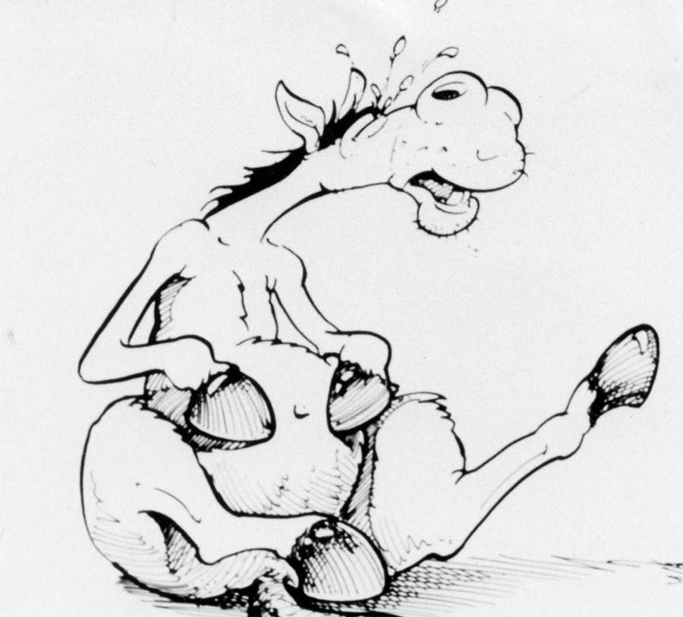



The Acorns Equine clinic, Pleshey, Chelmsford, Essex. CM1 3HU.
Tel. (01245) 231152, Fax. (01245) 231601.
www.essexhorsevets.co.uk

